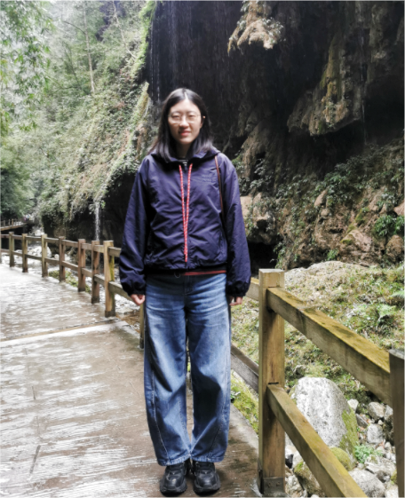
姓名：马长青 籍贯：山东青岛
政治面貌：中国共产党党员 职称：副教授
专业：果树学 学位：博士
毕业院校：西北农林科技大学
联系方式：201901143@qau.edu.cn；macqing@126.com
研究方向：果树生长发育、果实品质形成机理
工作经历：
2019-2025，青岛农业大学，园艺学院果树学专业，讲师
2025-至今，青岛农业大学，园艺学院果树学专业，副教授
承担科研项目:
- 国家自然科学基金青年基金项目，2026.01-2028.12，主持
- 山东省自然科学基金青年基金项目，2021.01-2023.12，主持
- 山东省自然科学基金面上基金项目，2025.10-2028.09，主持
- 校高层次人才科研基金项目，2021.01-2023.12，主持
主要发表论文：
- Jialong Wang, Dong Wang, Mingrui Zhao, Mengyuan Yu, Xiaodong Zheng, Yike Tian, Zhijuan Sun, Xiaoli Liu, Caihong Wang, Changqing Ma. A transcription factor, PbWRKY24, contributes to russet skin formation in pear fruits by modulating lignin accumulation. Horticulture Research. 2025, 12:uhae300
- Changqing Ma, Peihua Du, Yang Cao, Huaite Liu, Lisong Ma, Bowen Liang. Melatonin alleviates apple replant disease by regulating the endophytic microbiome of roots and phloridzin accumulation. Microbiological Research. 2024, 289:127897
- Changqing Ma, Chenjuan Jing, Bo Chang, Jiuying Yan, Bowen Liang, Li Liu, Yazhou Yang, Zhengyang Zhao. The effect of promoter methylation on MdMYB1 expression determines the level of anthocyanin accumulation in skins of two non-red apple cultivars. BMC Plant Biology. 2018, 18:108
- Changqing Ma, Bowen Liang, Bo Chang, Li Liu, Yazhou Yang, Zhengyang Zhao. Transcriptome profiling of anthocyanin biosynthesis in the peel of ‘Granny Smith’ apples (Malus domestica) after bag removal. BMC Genomics. 2019, 20:353
- Changqing Ma, Yang Cao, Yu wei Shang, Baoying Yin, Peihua Du, Shasha Zhou, Zhongyong Li, Jizhong Xu, Xueying Zhang, Bowen Liang. Melatonin enhances the tolerance of apple seedlings to salt stress by regulating the microbial community structure and metabolite composition of the rhizosphere. Plant and Soil. 2023, 497(1-2):483-483
- Changqing Ma, Xu Wang, Mengyuan Yu, Xiaodong Zheng, Zhijuan Sun, Xiaoli Liu, Yike Tian, Caihong Wang. PpMYB36 encodes a MYB-type transcription factor that is involved in russet skin coloration in pear (Pyrus pyrifolia). Frontiers in Plant Science. 2021, 12:776816
- Changqing Ma, Bowen Liang, Bo Chang, Li Liu, Jiuying Yan, Yazhou Yang, Zhengyang Zhao. Transcriptome profiling reveals transcriptional regulation by DNA methyltransferase inhibitor 5-aza-2'-deoxycytidine enhancing red pigmentation in bagged ‘Granny Smith’ apples (Malus domestica). International Journal of Molecular Sciences. 2018, 19, 3133
- Changqing Ma, Mengqi Wang, Mingrui Zhao, Mengyuan Yu, Xiaodong Zheng, Yike Tian, Zhijuan Sun, Xiaoli Liu, Caihong Wang. The Δ1-pyrroline-5-carboxylate synthetase family performs diverse physiological functions in stress responses in pear (Pyrus betulifolia). Frontiers in Plant Science. 2022, 13:1066765
- Changqing Ma, Chuanjie Bian, Wenjie Liu, Zhijuan Sun, Xiangli Xi, Dianming Guo, Xiaoli Liu, Yike Tian, Caihong Wang, Xiaodong Zheng. Strigolactone alleviates the salinity-alkalinity stress of Malus hupehensis seedlings. Frontiers in Plant Science. 2022, 13:901782
- Yang Cao, Peihua Du, Zhongyong Li, Jizhong Xu, Changqing Ma (共同通讯), Bowen Liang. Melatonin promotes the recovery of apple plants after waterlogging by shaping the structure and function of the rhizosphere microbiome. Plant Cell and Environment. 2024, 47(7):2614-2630
- Yang Cao, Jiran Zhang, Peihua Du, Jiahao Ji, Xue Zhang, Jizhong Xu, Changqing Ma (共同通讯), Bowen Liang. Melatonin alleviates cadmium toxicity by regulating root endophytic bacteria community structure and metabolite composition in apple. Tree Physiology. 2024, 44 (2):tpae009
- Bowen Liang, Changqing Ma (共一), Lianmei Fan, Yongzhang Wang, Yongbing Yuan. Compost amendment alters soil fungal community structure of a replanted apple orchard. Archives of Agronomy and Soil Science. 2021, 67 (6):739-752
- 马长青, 杨英杰. 观赏园艺学课程教学改革探讨. 高教学刊. 2022, 8 (11):153-156
- 马长青, 柏素花, 戴洪义. ‘嘎拉’苹果多酚氧化酶基因MdPPO的克隆与表达分析. 植物生理学报. 2013, 49 (8):803-810
- 马长青, 柏素花, 董超华, 张玉刚, 戴洪义. 苹果异分支酸合酶基因MdICS1的克隆与表达分析. 植物生理学报. 2016, 9(52):1361-1370
授权发明专利：
- 利用BSA-seq筛选与梨果实褐皮相关联分子标记方法, 国家发明专利, ZL202110167410.5, 1/6
- 独脚金内酯在提高植物抵抗缺钾胁迫能力方面的新应用, 国家发明专利, ZL202210836162.3, 1/6
- 一种与梨花粉败育性状相关联分子标记及其筛选方法, 国家发明专利, ZL202210960608.3, 1/8
- 一种新型复合物在提高植物抵抗干旱胁迫中的新应用, 国家发明专利, ZL202311149389.1, 1/7

